Jason Sim

Lab 3

Part 1 of Lab 3

1. 
   1. Created an SH file called Question1.sh
   2. Within the above file I added a grep command to solve question 1. 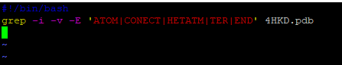
2. 
   1. Created sh file called Question2.sh
   2. Within the sh file I added a sed command per question 2. 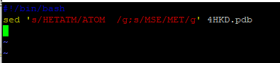
3. 
   1. The awk file above pulls all of the ATOM lines, and I saved the result into Question3.
   2. I created Question3A.sh to include the command lines to get the min and max values. 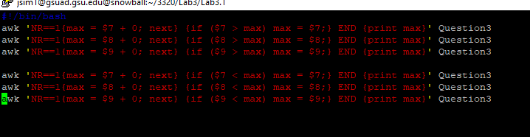
   3. Output of Question3A.sh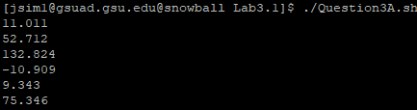
4. 
   1. The awk command line was saved to Question4.
   2. Created a Question4A.sh file. 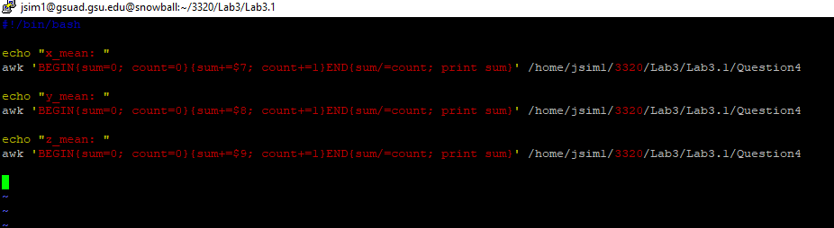
   3. Output of Question4A.sh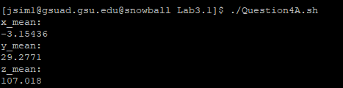
5. Created Question5.sh file
   1. 
   2. 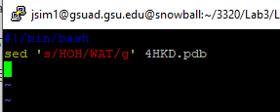
      1. This changes the HOH to WAT in 4HKD.pdb
6. 
   1. Pulling the ATOM records and assigning the result to Question6 file.
   2. 
      1. Sorting the ATOM record at the 11th position.
      2. Assigning the sorting to Question6A file.